CLIMATE CHANGE DEBATES AND INDIA’S RESPONSE TO INTERNATIONAL CLIMATE POLICY
DEBESH BHOWMIK
debeshbhowmik@rediffmail.com

INTERNATIONAL INSTITUTE FOR DEVELOPMENT STUDIES ,KOLKATA

Paper published in 93rd Conference of Indian Economic Association at Punjab University, Chandigarh, 27-29 Dec. 2010. The Indian Economic Journal Special issue,P-334-352.

CLIMATE CHANGE DEBATES AND INDIA’S RESPONSE TO INTERNATIONAL CLIMATE POLICY
DEBESH BHOWMIK
debeshbhowmik@rediffmail.com

INTERNATIONAL INSTITUTE FOR DEVELOPMENT STUDIES ,KOLKATA

Abstract
The contents of the first part of the paper shows the argument that GHG enhances global temperature is not exactly true as opposed by the Sun/Cosmic Ray Theory. Acceleration of CO₂ concentration in the air results sea level hike and even lowering of Penguin population and increase in Hurricane and Typhoon are not always true according to the researches of Climate Change Science.
The second part of the paper focused that from Kyoto to Copenhagen, the climate change negotiations failed because of USA’s non-ratification of Kyoto Protocol. Presently, IPCC,ICC,UNEP and UNCTAD believe that it is too late to frame global climate change policies and a global fund for reduction of emission. But, no agreement was signed in Copenhagen except in REDD and LULUCF. India’s response to international climate policy is clear that share of burden of emission should be borne equally by the developed and developing countries as per their historic content of emission. Besides , a global consensus is urgent. Although, India prepared a National Action Plan on climate change.

…………… JEL- Q54, Q56, Q58
Key Words – Climate change, CO₂ theory ,Sun/Cosmic Ray Theory ,International climate policy, India’s climate policy
CLIMATE CHANGE DEBATES AND INDIA’S RESPONSE TO INTERNATIONAL CLIMATE POLICY
Debesh Bhowmik
( International Institute for Development Studies ,Kolkata)
Introduction
Climate change is the major international problem or transboundary problem facing all countries of the world.The threat of climate change is not only global but also multidimensional, invisible,unpredictable and transcends national borders.It creates allocation problems on the areas of sustainable development, mitigation, adaptation and technology transfer .The climate change problem produces redistribution of international trade and international co-operation and even it can reform WTO.
The paper contains two parts,namely [1] concepts and debates over climate change and [2] India’s response to international Climate Policy.In the Part-I,the paper endeavours to explore that the increase in CO₂ does not necessarily cause to step up global temperature at all. The present researches and facts will prove its validity.In the Part-II,the paper will highlight India’s reaction to global climate change policies as envisaged in the successive summits .How, India did form its national policy in response to global policies will be the focal point in context of sustainable development.
Part-I
The Concepts and Debates of Climate Change
The Earth's history shows that the climate has always been changing, over both short-term and long-term time scales. These changes have sometimes been abrupt and severe, without any help from humans. Climate temperature reconstructions are determined from a variety of sources, such as from tree ring width studies and ocean floor sediments. During the last 2 billion years, the Earth has alternated between cool periods like today, and warm periods like when the dinosaurs roamed the planet. The figure -1 below on the left is a temperature reconstruction of the Earth over 2 billion years. Temperatures over this time frame are determined by mapping the distribution of ancient coals, desert deposits, tropical soils, salt and glacial deposits, as well as the distribution of plants and animals that are sensitive to climate, such as alligators, palm trees & mangrove swamps.

Figure -1
The northern hemisphere temperature history since the last ice age
Source-Gregory(2010)
IPCC has published the history of temperature of the world during 1000 years which is given below in the Figure-2 where it was found that the path of the temperature is cyclical.

Figure – 2
History of Temperature
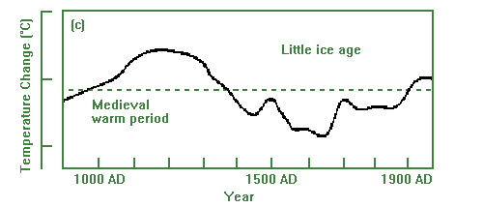
Source-Gregory(2010)
The temperature of the Earth has warmed slightly, about 0.7 degrees Celsius, over the last hundred years. Over this time, CO₂ concentration in the atmosphere has increased, mostly due to the increased use of fossil fuels. However, the Sun has increased in intensity since 1900 which may have induced much of the observed warming since then. It was estimated that the Sun may have caused 10 to 20% of the increase in CO₂ during the last century. A short-term correlation does not imply that the CO₂ increase caused the temperature increase. The actual climate history shows no such correlation, and there is no compelling evidence that the recent rise in temperature was caused by CO₂. Temperatures have been variable over time, and do not correlate to CO₂ concentration. When CO₂ concentrations were 10 times higher than they are now we were in a major ice age.
The actual increase of CO₂ concentration averaged 0.5% per year since 1990.
It is shown in the Figure-3.
Figure-3
The growth rate of CO₂.
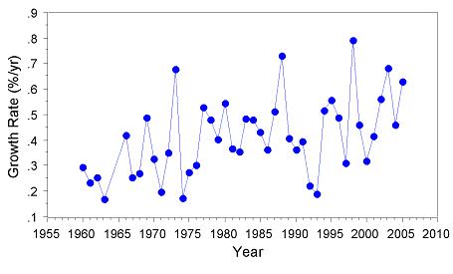
Source-Gregory(2010)
Numerous papers published in major peer-reviewed scientific journals shows the Sun is the primary driver of climate change. There is a very strong correlation between the Sun activity and temperature. The researchers have shown that the length of the mean 11 year Sunspot cycle correlates to the northern hemisphere temperature during the past 130 years. The length of the Sunspot cycle is known to vary with solar activity, whereas high solar activity implies short sunspot cycle length.In the Figure-4,we have shown the correlation of the sunspot cycle length, global temperature and CO₂ concentrations. The red squares on the graph represent the sunspot cycle lengths. One point is the cycle length from the time of the maximum number of sunspots to the time of the maximum number of sunspots of the next cycle, and the following point is the cycle length from the time of the minimum number of sunspots to the time of the minimum number of sunspots of the next cycle. The sunspot cycles are back filtered using weighting 1,2,3,4 applied to each cycle point, both min to min and max to max. This assumes that the current cycle has the most effect on temperature (weight 4), and previous half cycles affect current temperatures in declining amounts, but future cycles have no effect on the current temperature. The temperature curve in blue used the HadCRUT3 land and sea data to 1978, the MSU satellite data from 1984 to 2006, and the average of the datasets for 1979 to 1983. Note that there is a correspondence between sunspot cycle length and temperature. Both the temperature and the cycle length curves begin to rise at 1910, and temperatures fall after 1945 to 1975 when the cycle length curve falls, and both curves rise again after 1975. Temperatures have been increasing since 1980 faster than can be explained by the sunspot cycle length, indicating a possible human CO₂ contribution. The recent increase of the cycle lengths explains why there has been no warming since 2002. Temperature changes are expected to follow Sun activity changes due to a time lag resulting from the large heat capacity of the oceans. The authors' analysis shows the Sun has contributed 50 to 69% of the surface warming depending on the reconstructions utilized. The remainder may be due to CO₂, UHI and land use changes.

Figure-4
Sunspot Cycle Length Temperature and CO₂
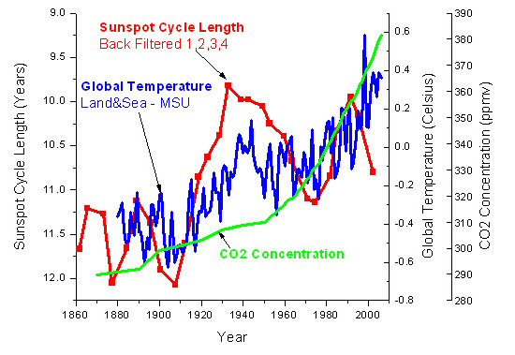
Source-Gregory(2010)
Recently, Tim Patterson, an adviser to the FOS, has studied high-resolution Holocene climate records from fjords and coastal lakes in British Columbia and demonstrates a link between temperature and solar cycles. The spectral analysis shown here is from sediment cores obtained from Effingham Inlet, Vancouver Island, British Columbia. The annually deposited laminations of the core are linked to the changing climate conditions. The analysis shows a strong correlation to the 11-year sunspot cycle.

Figure-5

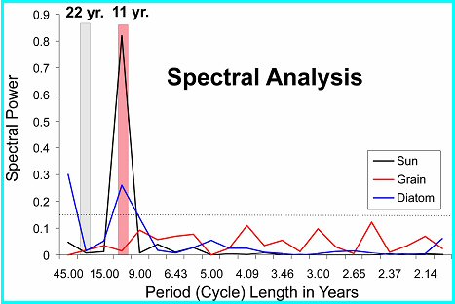
Source-Gregory(2010)
During the 20th century the Sun has continued to warm and may have contributed directly to a third of the warming over the last hundred years. The change in solar output is too small to directly account for most of the observed warming. However, the Sun-Cosmic Ray connection provides an amplification mechanism by which a small change in solar irradiance will have a large effect on climate.
Data from the International Satellite Cloud Climatology Project and the Huancayo cosmic ray station shows a remarkable correlation between low clouds (below 3 km) and cosmic rays. There are more than enough cosmic rays at high altitudes, so changes in the cosmic rays do not effect high clouds. But fewer cosmic rays penetrate to the lower clouds, so they are sensitive to changes in cosmic rays.
The blue line shows variations in global cloud cover collated by the International Satellite Cloud Climatology Project. The red line is the record of monthly variations in cosmic-ray counts at the Huancayo station.Cosmic ray flux can be determined from radioactive isotopes such as beryllium-10, or the Sun’s open coronal magnetic field. The two independent cosmic ray proxies confirm that there has been a dramatic reduction in the cosmic ray flux during the 20th century as the Sun has gained intensity and the Sun's coronal magnetic field has doubled in strength. Figure-6 can justify the above analysis.

Figure – 6
Cosmic Rays and Low Clouds
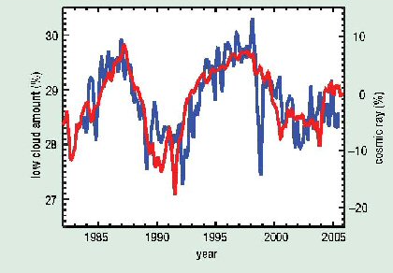
Source-Gregory(2010)
When the Sun is active it has a higher number of sun spots and emits more solar wind - a continuous stream of very high-speed charged particles. The increased solar wind and magnetic field repels cosmic rays that otherwise would hit the Earth's atmosphere, resulting in less aerosols in the lower atmosphere thereby reducing low cloud formation. The low clouds have a high reflectivity and have a strong cooling effect by reflecting sunlight back into space.
In summary, the process is:
More active Sun --> more Sunspots --> more solar wind --> less cosmic ray --> less aerosols --> less low clouds --> more sun light to the surface --> global warming.
The theory of CO₂ warming implies that the arctic and Antarctica should be warming about the same, and the polar regions should be warming more that the rest of the Earth. However, Antarctica has not warmed since 1975, which is a big problem for the CO₂ theory. The ice covering Antarctica has even higher reflectivity than low clouds, so fewer low clouds cools Antarctica, while fewer low clouds warms the rest of the planet. (Greenland's ice sheet is much smaller and is not so reflective.) This Antarctica temperature trend is strong evidence that the Sun, not CO₂, is the primary climate driver.It is clearly shown in Figure-7

Figure-7
Antarctica and North America Temperature Trends
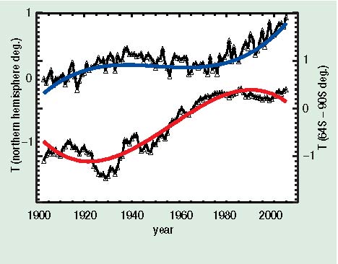
Source-Gregory(2010)
The top curve is the North American surface temperature and the bottom curve is the Antarctica (64 S - 90 S) surface temperature over the past 100 years. The Antarctic data have been averaged over 12 years to minimize the temperature fluctuations. The blue and red lines are fourth-order polynomial fits to the data. The curves are offset by 1 K for clarity, otherwise they would cross and re-cross three times.
The cosmic ray flux is not only influenced by the solar wind, it also varies with the position of the solar system in the galactic arms. The solar system passes through the arms of the Milky Way galaxy roughly every 140 million years. When the solar system is in the galactic arms the intensity of cosmic rays increases, as we are closer to more supernovas that give off powerful bursts of cosmic rays. The variations of the cosmic ray flux due to the solar system passing through four arms of the Milky Way galaxy during the last 550 million years is ten times greater than that caused by the Sun. The correlation between cosmic rays and temperatures over 520 million years which was shown previously. Below is a similar graph based on their work, but with the times of the galactic arm crossings shown.
The MSU curve is the Microwave Sounding Unit satellite measurements. It measures the temperature of the troposphere up to approximately 8 km.The GHCN curve is the Global Historical Climatology Network data set of land surface temperatures from the National Climatic Data Center.The HadCRUT3 curve is the Land and Sea-Surface Temperatures data set from UK Met Office.The three curves are scaled so that the average of the first 5 years are the same.

Figure-8
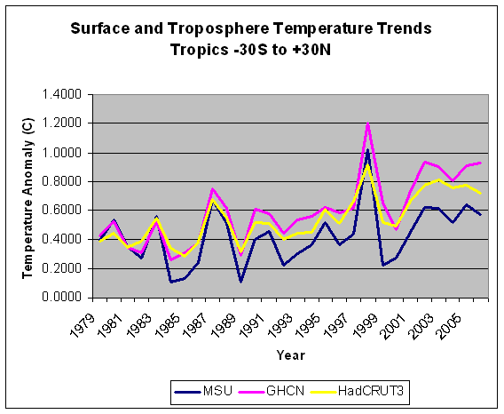
Source-Gregory(2010)
The graph "HadAT2 Radiosonde Data 1979 - 1999" in the previous section shows that the stratosphere (above 16 km) has cooled, which might appear to indicate a greenhouse gas effect. However, stratospheric cooling is predicted to occur due to both greenhouse gasses and ozone depletion. The ozone concentration in the stratosphere has declined from 1970 until 1995, and has not declined at all since then due to the implementation of the Montreal Protocol, which limits the emission of ozone reducing CFCs.
The lower stratosphere temperature has not declined at all since 1995 (when the ozone levels are stable or slightly increasing), so the data does not indicate any greenhouse gas cooling of the stratosphere. In fact, it appears that there has been a slight warming of the lower stratosphere since 1995, the opposite of what is predicted by computer models of the greenhouse gas effects. The stratosphere cooling indicated by the radiosonde data is caused by the changing ozone concentration, not by greenhouse gasses.(Figure-9).
Figure-9 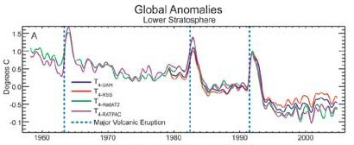
Source-Gregory(2010)
Thus,the following table sets out a comparison of the predictions of two climate theories - the CO₂ warming theory and the Sun/Cosmic Ray theory - and actual real world data.
Table-1
CO₂ Theory Vs Sun/Cosmic Ray Theory
Issue | Prediction - CO₂ Theory | Prediction - Sun/Cosmic Ray Theory | Actual Data | Which Theory Wins
Antarctic and Arctic Temperatures | Temperatures in the Arctic and Antarctic will rise symmetrically | Temperatures will initially move in opposite directions | Temperatures move in opposite directions | Sun/Cosmic Ray
Troposphere Temperature | Fastest warming will be in the troposphere over the tropics | The troposphere warming will be uniform | The surface warming is similar or greater than troposphere warming | Sun/Cosmic Ray
Timing of CO₂ and Temperature Changes at End of Ice Age | CO₂ increases then temperature increases | Temperature increases then CO₂ increases | CO₂ concentrations increase about 800 years after temperature increases | Sun/Cosmic Ray
Temperature correlate with the driver over last 400 year | na | na | Cosmic ray flux and Sun activity correlates with temperature, CO₂ does not | Sun/Cosmic Ray
Temperatures during Ordovician period | Very hot due to CO₂ levels > 10X present | Very cold due to high cosmic ray flux | Very cold ice age | Sun/Cosmic Ray
Other Planets' Climate | No change | Other planets will warm | Warming has been detected on several other planets | Sun/Cosmic Ray
Source-Gregory(2010)
Debates over effects of global warming
There has been no change in the rate of sea level rise in the last 100 years as shown below.
In Figure-10,it was seen that Mean global sea level (gsl) (top), with its shaded 95% confidence interval, and mean gsl rate (bottom), with its shaded standard error interval.
The IPCC AR4 estimates that "Global average sea level rose at an average rate of 1.8 [1.3 to 2.3] mm per year over 1961 to 2003. The rate was faster over 1993 to 2003, about 3.1 [2.4 to 3.8] mm per year." It also states "There is high confidence that the rate of observed sea level rise increased from the 19th to the 20th century."
Since August 1992 the satellite altimeters have been measuring sea level on a global basis. The University of Colorado at Boulder provides data from a series of satellites. Tide gauge calibrations are used to estimate altimeter drift. The global sea level rise with the seasonal signal removed is shown here. It shows a trend from 1992 thru March 2009 of 3.1 mm/year. Below are graphs of global, Pacific ocean and Atlantic ocean sea levels, with trends from January 2004 to March 2009, seasonal signals included.(Figure-10)
Note that there has been a significant flattening of the trend since 2004. The global sea level rise since January 2004 of 1.52 mm/year is less than half of the overall trend from 1992 of 3.1 mm/year. The trends since January 2004 of the Pacific and Atlantic oceans are 0.15 mm/year and 0.37 mm/year, respectively. The slowing of the sea level rise is consistent with the current lack of global warming.(Figure-10)
Dr. Morner says the global sea level has been rising at 1.1 mm/year from 1850 to about 1940, then no increase to 1970. The IPCC uses a tide gauge in Hong Kong that shows 2.3 mm/year of sea level rise. The tide gauge is located where the land is known to be subsiding, so the record should not be used. Satellite altimetry data from the TOPEX/POSEIDON mission measures the sea level relative to the centre of the Earth (rather than relative to the coast) since 1992.

Figure-10
Sea Level
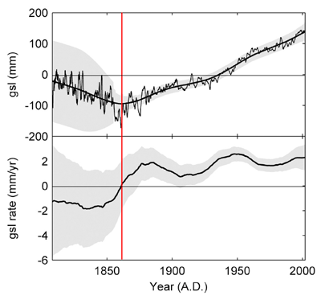
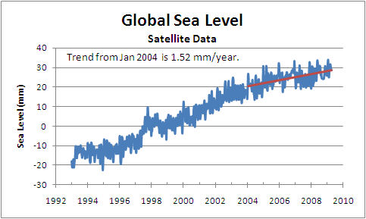
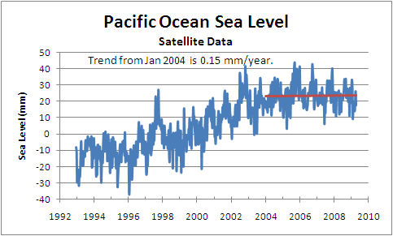
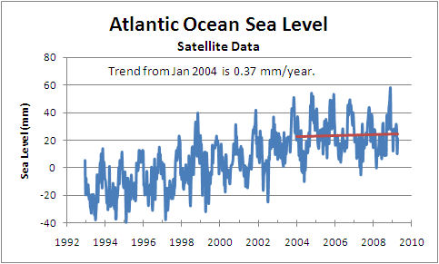
Source-Gregory(2010)
The IPCC claims that global warming will result in more severe weather. This doesn't make any sense, as most storms are caused by a difference in temperatures of colliding air masses. If CO₂ warms the Polar Regions there will be smaller temperature differences, and less severe storms. All other things being equal, a warmer world should have fewer, not more, severe storms.
Unlike most storms, hurricanes are caused by difference in temperatures between the sea surface and the storm top.

Researchers examined a suite of climate models and found that they virtually unanimously projected that in a CO₂-enhanced world, the middle and upper troposphere will warm at a faster rate than the surface, especially over the tropical oceans. More warming aloft than at the surface makes the atmosphere more stable and less conducive to storm formation. Thus, the model-projected vertical stability increases in the future would temper (but not totally cancel out) the increase in storm intensity by rising sea surface temperature.However, researchers found that the climate models almost unanimously project that there will be an increase in the vertical wind shear during the hurricane season which also acts to inhibit tropical cyclone formation. The combined result is that any increase in hurricane intensity will be so small as to be undetectable. Incidentally, the actual vertical wind shear of Atlantic hurricanes have been declining since 1973, the opposite of the trend predicted by the climate models.
There is absolutely no evidence of increasing severe storm events in the real world data. Here is a graph of hurricane intensity for the USA.
Figure-11
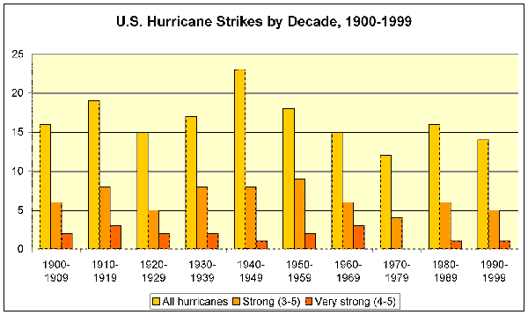
For the North Atlantic as a whole, according to the World Meteorological Organization, "Reliable data ... since the 1940s indicate that the peak strength of the strongest hurricanes has not changed, and the mean maximum intensity of all hurricanes has decreased."
Global hurricane activity has continued to sink to levels not seen since the 1970s. In the Southern Hemisphere the 2008 ACE has fallen to 58% of the 2005 ACE index. During the past 60 years Northern Hemisphere ACE undergoes significant interannual variability but exhibits no significant statistical trend. The northern hemisphere 2008 ACE was 85% of the 2005 ACE as shown in the stacked bar chart below.
Figure-12
Source-Gregory(2010)
NCEP/NCAR reanalysis data since 1958 studied the occurrence of winter storms over the northern hemisphere. They found a statistically significant (at the 95% level) decline of 1.2 cyclones per year for the period, during which temperatures reportedly rose in much of the hemisphere."Global warming causes increased storminess" makes for interesting headlines. It also violates fundamental scientific truth and the lessons of history.
Global hurricane activity has decreased to the lowest level in 30 years. The Accumulated Cyclone Energy (ACE) is the combination of a storm's intensity and longevity.
As indicated previously, both higher temperatures and CO₂ concentrations enhance plant growth, especially for trees. This increases the habitat available for many animals. The bulk of scientific studies show an increase in biodiversity almost everywhere on Earth that is not restricted by habitat destruction in response to global warming and atmospheric CO₂ enrichment.
The global warming alarmist has picked the polar bear as its poster animal. Time magazine has told its readers that they should be worried about polar bear extinction. The data however, does not support reasons for concern. In the Baffin Bay region between North America and Greenland, temperatures have been declining and the polar bear population has declined. In the Beauford Sea region the temperature has increased and so has the polar bear population. In other areas the polar bear population has been stable. So the trend of polar bear populations relative to temperature have been opposite to what Time would lead its readers to believe.
There has been recent warming in the western arctic as a result of the Pacific Decadal Oscillation, which periodically shifts the climate in the western arctic by changing ocean currents. These cycles have occurred over thousands of years. No evidence exists that suggests that both polar bears and the conservation systems that regulate them will not adapt and respond to the new conditions. Polar bears have persisted through many similar climate cycles.
In context to misallocation of funds ,we can say that of all the major problems of the world, climate change is one of the least important because funds spent to reduce CO₂ emissions will have an insignificant effect on climate. Computer model projections show that full implementation of the Kyoto Protocol may result in temperature reduction of an undetectable 0.06 Celsius by 2050 at a cost of about $1,000,000,000,000 US. (This estimate assumes the sun has no effect on climate. Since the sun has a major effect, the 0.06 Celsius estimate is likely high by a factor of 2 or more.)
The Copenhagen Consensus (directed by environmentalist Bjorn Lomborg) analysed the major challenges facing the world and produced a prioritized list of opportunities responding to those challenges. Submission by 24 United Nations ambassadors and other senior diplomats were reviewed by economists and determined that the top priority for addressing major world challenges would be given to communicable diseases, sanitation and water, malnutrition, and education. Ranked toward the bottom of the 40-category list were issues relating to climate change and the Kyoto Protocol.
We may note some of the errors about global warming which are given below.
It is said that a doubling of pre-industrial CO₂ levels to 560 ppm will so acidify sea water that all optimal areas for coral reef construction will disappear by 2050. This is not plausible. Coral calcification rates have increased as ocean temperatures and CO₂ levels have risen, and today’s main reef builders evolved and thrived during the Mesozoic Period, when atmospheric CO₂ levels hovered above 1,000 ppm for 150 million years and exceeded 2,000 ppm for several million years.
It is argued that the rate of global warming is accelerating, whereas the rate has been constant for the past 30 years to 2002—roughly 0.17°C per decade, and no warming from 2002 through 2006.
Assumes a linear relationship between CO₂ levels and global temperatures, whereas the actual CO₂-warming effect is logarithmic, meaning that the next 100 ppm increase in CO₂ levels adds only half as much heat as the previous 100 ppm increase.(Figure-13).Red bars indicate temperature above and blue bars indicate below the average temperature for the period 1901-2000.The black line shows atmospheric CO₂ concentration in ppm.
Some blame that global warming for the decline “since the 1960s” of the emperor penguin population in Antarctica, implying that the penguins are in peril, their numbers dwindling as the world warms. In fact, the population declined in the 1970s and has been stable since the late 1980s.

Figure-13
Source- www.global change .org
Part-II
International Policy Issues
Achieving a medium probability of staying below 2° Celsius, after implementation of the Kyoto Protocol, would require global emissions to decrease by 1 to 2 per cent per year over several decades. Delaying reductions until2015 would increase this to 3 to 4 per cent per year.
And putting off global action until 2020 would make it virtually impossible to hit this target. This is clearly a big challenge – but it is achievable, given the political will. The first step was the entry into force of the Kyoto Protocol. There is a tremendous chance to shape the way the coming $16 trillion of investments in energy sector investments (estimated by the International Energy Agency) will be made. A signal has now been sent to the carbon markets that the Kyoto Protocol is, and will remain, the basis for negotiations. But much more certainty needs to be provided so that that this vast sum will be channelled into energy systems that emit zero, or very little, carbon.(Jennifer Morgan,2010).
11th Annual Global Development Conference Organized by the Global Development Network [(GND) January 16-18, 2010 Prague] declared that it is time to start a new deal on climate change beginning with a re-evaluation of the indicators of economic growth believing that economic deregulation must end, resonating with the way in which economic integration will take place in the future.
ICC recommends that all governments:
• reject and avoid unilateral trade measures as a policy option to deal with climate change;
• ensure alignment and mutual compatibility between climate change and trade policies by
developing climate change policies that promote sustainable development, while safe guarding an open and non-discriminatory multilateral trading system and guaranteeing the integrity of WTO disciplines;
• eliminate trade barriers to environmental goods and services;
• ensure strong protection of intellectual property rights to facilitate diffusion of clean technologies and provide an incentive for innovation; and
• work cooperatively, including with business and civil society, to reach agreement on an
effective post-2012 global framework that includes all major emitters to meet the challenge of
climate change under the UNFCCC process , and that functions harmoniously with WTO rules and the multilateral trading system.
UNCTAD believes that developing countries, although they face considerable costs, can also generate new income if they adapt their development strategies to the requirements of climate change mitigation. This policy brief also stresses the role of government in facilitating the process of structural change, not only by fostering “green” consumer preferences, but also by implementing pro-active industrial policies that support the production of climate-friendly equipment and appliances. In short: The world can move to a low-carbon economy without feeling paralysed by the costs – and can do so without sacrificing growth in the developing world.(UNCTAD Policy Brief,2009).
COP15 discussed to reduce 50% emission by 2050 and to create a fund but no agreement was signed except on forest management and it was ended with a war between developed and developing countries.

India’s response to climate change
The impact of Climate Change is so far-reaching that no country can now afford to sit on the sidelines. India, with 17 per cent of the world’s population,contributes only 4 per cent of the total global greenhouse gas emissions against30% approx. of the US and 25% of the EU countries. In terms of per capita GHG emissions, India is further lower at only 1.1 MT CO₂ (about 23% of the
global average) as compared with the per capita emission of 22 MT CO₂ in US and 15 MT CO₂ in EU.
It has been India’s stand not to agree to any commitments related to reducing greenhouse gas emissions. India stands for equity in global negotiations on climate change. India believes that since developed countries are more responsible for the problem, owing to their historical as well as current emissions, they must deliver on their commitments to stabilize and reduce their emissions of GHGs.India is committed to a path of sustainable development. Though India’s per
capita emissions are lowest in the world, we have recently adopted a National Action Plan on Climate Change
India has been pressing at the UN Framework Convention on Climate Change and other international conferences for collaborative development of clean technologies and immediate transfer of existing technologies which are environment friendly. India has also been trying to impress upon developed countries to transfer environmentally sound and cleaner energy technologies into the limited public domain for use by developing countries for early adoption,
diffusion and deployment accompanied with transfer of financial resources. India had also called for early operationalization of the Adaptation Fund and Special Climate Change Fund under the United Nations Frame work Convention on Climate Change for addressing Climate Change issues in the developing countries. India is a partner to the new Asia Pacific Partnership on Clean Development and Climate which consists of key developed and developing countries—Australia, China, Japan, South Korea and the USA besides India. It focuses on development, diffusion and transfer of clean and more efficient technologies and is consistent with the principles of the UNFCCC and complements the efforts under the UNFCCC and will not replace the Kyoto Protocol. The Ministry of Environment and Forests is the nodal agency for climate change issues in India. India has initiated several climate-friendly measures, particularly in the area of renewable energy India had adopted the National Environment Policy 2006 which provides
for several measures and policy initiatives, to create awareness about climate change and help capacity building for taking adaptation measures. The National Forest Policy also envisages active measures for expanding carbon sinks through increase in forest and tree cover to 25 per cent by 2007 and 33 per cent by 2012. A major afforestation programme covering 6 mn hectares has been launched under the XIth Plan for this purpose. On 30th June 2008 India unveiled its National Action Plan on Climate Change (NAPCC) The National Action Plan identifies measures that promote our development objectives while also yielding co-benefits for addressing climate change effectively. Eight national missions (solar mission, energy efficiency, sustainable habitat, water, Himalayan ecosystem, green India, Eco-green agriculture and knowledge) have been specifically outlined to simultaneously advance India’s development and climate change related objectives of adaptation and GHG mitigation. However, we have not set any quantitative goals towards emission reduction , the Government has set up an “Expert Committee on Impacts of Climate Change” on 7 May 2007 under the chairmanship of Dr. R. Chidambaram.
Moreover, a Council has also been set up under the Chairmanship of the Prime Minister of India on 6 June 2007 constituting eminent persons to evolve a coordinated response to issues relating to climate change at the National level and provide oversight for formulation of action plans in the area of assessment. Government has initiated “Green India” programme which envisages undertaking massive afforestation of degraded forests land in the country. Financial resources to be mobilized include funds available under “Compensatory Afforestation Fund Management and Planning Authority (CAMPA)”, mobilising funds from the market, developing partner associations, and income from tree felling at ecologically appropriate intervals. The “Green India” programme will cover about six million hectare in the country in about 10 years.
India has made written submissions to the UNFCCC on each of the following issues :
( i) Submission on Long Term Co-operative Action,(ii) Submission on enhancing action on Adaptation,(iii) Financing Architecture for Meeting Financial Commitments under the UNFCCC, (iv) Submission on Technology Transfer Mechanism,(v) Submission on Mitigation Actions of Developing Countries, under Paragraph 1 (b) (ii) of the BAP,(vi) Submission on Measurement, Reporting and Verification (MRV) – under Bali Action Plan (BAP) 1 (b) (i) (vii) Submission on Reduced Deforestation in Developing Countries (REDD), Sustainable Forest Management (SFM), and Afforestation And Reforestation (A&R), Under the Bali Action Plan (BAP),(viii) Submission on Nationally Appropriate Actions of Developing countries,(ix) Submission on financing Flows (Why Financial Contributions to the Financial Mechanism of the UNFCCC cannot be under the Paradigm of “Aid”.
Because,India believes that global action on Climate Change, based on the UNFCCC, is not conditional upon maintenance of trade competitiveness or level playing fields.India also believes that investment in addressing Climate Change, especially in renewable energy, could create new industries,new jobs and spur technological innovation. Action on Climate Change must become part of the solution to the financial and economic crisis, in its causality. It is in this context, that India has welcomed US President Obama’s plan for a 10-year, US$ 150 billion Renewable Energy Initiative and expressed its readiness to become an active partner.
In response to IPCC projection on [i] The science of climate change; climate modelling and projections (Working Group-I).[ii] Impacts, vulnerability and adaptation to climate change (Working Group-II).[iii] Mitigation and policies (Working Group-III),India has completed four nationally coordinated assessments of climate change projections, impacts and mitigation;[a] the climate change studies supported by the Asian Development Bank, [b] the ALGAS (Asian Least-Cost Greenhouse Gas Abatement Study) supported by the Global environment Facility(GEF),[c] climate impact assessment study conducted under the Indo-UK collaborative project and [d] the National Communications supported by the GEF. Moreover, Research and Development (R&D) groups have been working on various aspects of climate change science, particularly the modelling aspects of GHG emissions.

Conclusion
The effort of Copenhagen Summit approved that USA became the topmost country who’s CO₂ emission is 25.2% of the world followed by China(15.2%), Russia(6.7%),Japan(5.4%),and India(4.4%).To reduce the carbon dioxide the previous summits failed to commit reduction target as USA refused to ratify Kyoto Protocol. Hence from Rio to Kyoto, the series of emission targets and agreements were kept ineffective because USA rolled two steps backward and the developing countries bargained with developed one collectively without forming any global policy.
Copenhagen tried to set up a global fund for emission. EU, Japan, RIC and Australia committed to cut down emission. They said that all countries should reduce emission by 50% within 2050 including to reduce 2⁰C temperature. The developing countries will be able to spend 30 billion dollar per year against deforestation, polluted industries and climate change while the developed countries will spend 100 billion dollar each year. The Summit has successfully ratified the policies on sustainable forest management on the agreements of REDD and LULUCF which can prevent climate change at a speedier rate. It has given a great emphasis on food security, bio-diversity and sustainable development. Yet no agreement was signed on each level. It means that Copenhagen failed to solve the problem of climate change and could not reach a concluding policy framework globally due to developing countries dominance on negotiations in their favour and competitions among the rich nations.USA flexibly ran with the RIC and South Americans but could not reach to any consensus.The Summit ends in a goalless target on global warming with a marginal success on forest management although developed countries hide 2% CO₂ emission from estimating LULUCF.On the other hand,the high cost REDD to the developing countries may produce new poor when implemented. Moreover the draft of REDD is not unique .It may threat to the poor nations.
As regards international trade is concerned,the OECD were able to maintain their status quo on the environmental goods and the WTO may not find any obligations towards their target to reduce tariff and non-tariff barriers on such goods.Since MEA is satisfying the interests of the rich nations on environmental goods and the foreign investment towards the developing countries,so Copenhagen via WTO will help the turn over of the rich nations in international trade.
So,the environment problem which is nothing but the transboundary problem and from which environmental goods are traded globally, is not being dominated by the developing countries presently as Copenhagen showed so.
But,what next? What is the following process of negotiations on climate change policies,combating warming process,solving food insecurity and trading agreements of environmental goods? To search the political solutions,it is necessary to look over economic security and economic integration status of the global economy.Hence, we hope that next summit on climate change must deal with the following:
- To set up a global fund.
- The share of fund may be fixed as per GNP
- To fix minimum expenditure on preventing climate change,reforestation and environmental goods in every country
- To monitor the policies on each return
- To check food insecurity ,global distribution of food is urgent and can be controlled by FAO
- IPCC is responsible to co-ordinate in each government and in each summit.
- To formulate forest management policies by every government
- To commit expenditure on forest management every year
- Global expenditure on forest management is to be formulated through a fund
- To fix emission target decade by decade on the part of each nations.
- Global summit is necessary on every six month.
- Long-term emission target is to be calculated by all nations

References

Bhowmik,Debesh(2001)-Environment,sustainable development and women’s poverty.
G.S.Monga(ed):Environment and Development.(Deep and Deep,NewDelhi), pp154-60.
…………….(2002)-Imperialism and WTO:A view from Labour Standard and Environment. 22nd
Conference Volume-Bengal Economic Association,Presidency College,Kolkata,pp49-60.
……………..(2008)-Global Warming,Sustainable Development and WTO.91st conference
volume-Indian Economic Association, Udaypur.
…………….(2009)-A short note on policies relating to climate change-Paper presented in
International Seminar on Feb 20-21,2009 at Rabindra Bharati University ,( Centre for
Studies on Environment and Sustainable Development ),Kolkata
…………….(2010):Issues on Forest Management and Climate Change –Paper presented in
International Seminar on Feb 27-28,2010 in Centre for Studies on Environment and Sustainable Development ,Rabindra Bharati University,Kolkata
Economist(2009)-Stopping climate change.3/12/09
EIRIS(2009)-Climate Change Compass:The Road to Copenhagen.August.
Government of India(2009):Road to Copenhagen:India’s Position on Climate Change Issues.
Gregory,Ken(2010): Climate Change Science.Canada.
ICC (2009) : Recommendations on trade and climate change Document No. 103/291 – 23
February 2009

Intergovernmental Panel on Climate Change.(1996). Climate Change 1995: Impacts,Adaptations
and Mitigation of Climate Change: Scientific-Technical Analyses, ed. Robert T.
IPCC (Intergovernmental Panel on Climate Change.( 2007)b. Summary for Policymakers.
Climate Change 2007: Climate Change Impacts, Adaptation, and Vulnerability. Working GroupII Contribution to IPCC Fourth Assessment Report: Climate Change 2007. Geneva (April 6).
IPCC Second Assessment Report:Climate Change(1995). Cambridge, UK: Cambridge
University Press.
IPCC(2007)b.-Summary for Policymakers,Climate change2007:Climate change impact,
Adaptation,and Vulnerability.Working group-II,Geneva.April.
International Union for Conservation of Nature(IUCN)(2009)- A Good Practice Guide :
Sustainable Forest Management Bio-diversity and Livelihoods.Convention on Biodiversity .Montreal.
IISD(2007)-The Climate Change and Foreign Policy.IISD,Canada.
Liddell,Greg(2009):Climate Change From Kyoto to Kopenhagen - Consulting and Advisory
Services, Australia ,Novenber, 2009

Mendelsohn,Robert(2009): Climate Change and Economic Growth.World Bank Working Paper
No-60,2009
Morgan,Jennifer(2010): Political Will.WWW International.Climate Change Programme.
Rajya Sabha Secretariat (2008): Climate Change:Challenges to Sustainable Development in
India. Occasional Paper Series(3),October,2008
Stern Review.( 2006). Stern Review Report on the Economics of Climate Change, by Nicholas Stern.Prepublication edition available at www.hm-treasury.gov.uk. Published edition available as The Economics of Climate Change: The Stern Review. Cambridge, UK: Cambridge University Press, 2007.
Stern Review(2007)-Stern Review Report on Economics of Climate Change.Cambridge
University Press,UK.
The Jakarta Post(2009)-Will the forestry sector be pretty in Copenhagen? 08/12/09
UNPCCC(2008)-Climate Change –the fight for Asia’s Future .Development in Asia.No-1,
June.
UNCTAD(2009): UNCTAD policy brief, December 9,2009
William R.Cline.(2007)-Global Warming and Agriculture:Impact Estimates by Country.
(Washington,International Economics,2007).
World Bank(1992)-World Development Report-1992
Yoshiki,Yamagata(2009)-Initial Discussion on Possible Post 2012 LULUCF Options. Climate
Change Research Project.National Institute for Environmental Studies, Japan
YEPP(2009)-Resolution on the UN Climate Change Negotiations in Copenhagen.5/9/09

JEL- Q54,Q56,Q58 : Key Words – Climate change,CO₂ theory ,Sun/Cosmic Ray Theory ,International climate policy, India’s climate policy
For details ,see www.friendsofscience.org
See www.friendsofscience.org
See Gregory(2010)
See www.friendsofscience.org
See Gregory(2010)
See www.friendsofscience.org
For details please see www.friendsofscience.org
See Bhowmik(2010)
Interested readers may consult with the book - Economics of Poverty(2007) by the author and An Introduction to Food Security and Climate Change (2010) by the same author’s paper which was presented in the BEA Seminar on 19-09-2010 at Netaji Nagar College ,Kolkata.

